**Exercise 3: Assertions in Junit**

* Create a test class in the test directory and name it meaningfully (e.g., AssertionsTest.java). This class will hold all your unit test methods.
* Create a public method inside the class and annotate it with @Test to mark it as a test case.

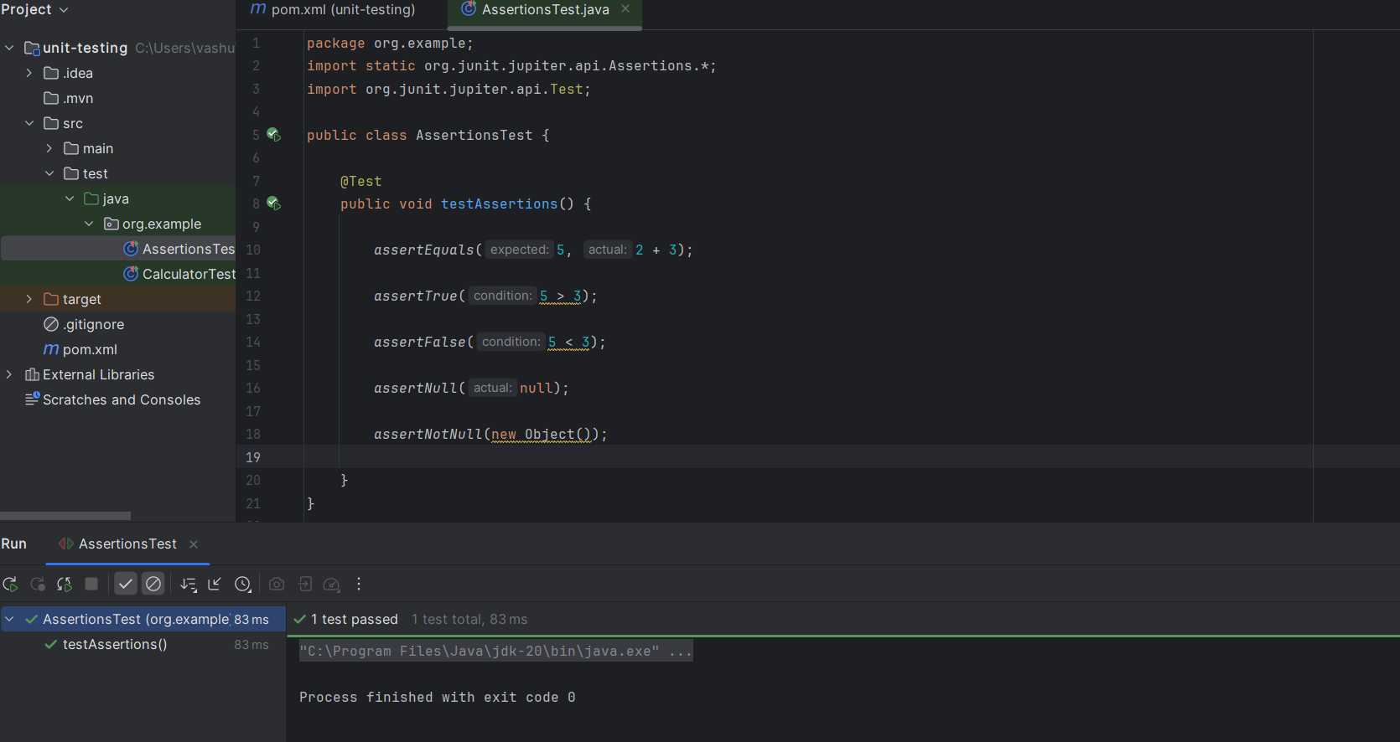

**JUnit Assertions**

1. assertEquals(expected, actual)

* Checks if the expected value is equal to the actual result.
* **Use Case:** Useful for comparing return values, calculations, etc.

1. assertTrue(condition)

* Verifies that the given boolean condition is true.
* **Use Case:** Used to check conditions or logical expressions.

1. assertFalse(condition)

* Verifies that the given boolean condition is false.
* **Use Case:** Used to assert that something is not happening.

1. assertNull(object)

* Verifies that the provided object is null.
* **Use Case:** Used when expecting a null reference or value.

1. assertNotNull(object)

* Verifies that the object is **not** null.
* **Use Case:** Used to ensure that objects are properly instantiated.